Name: Umair Khan
Course Name: Python
Assignment 2
Python Basics Assignment
Python Programming Practical –
1. Grade Checker
Step 1: Take a score as input
score = int(input("Enter your score: "))
Explanation: The input() function is used to take the score from the user. The int() function converts the entered score into an integer.
Step 2: Check the grade using if-elif-else
if score >= 90:
print("Grade: A")
elif score >= 80:
print("Grade: B")
elif score >= 70:
print("Grade: C")
elif score >= 60:
print("Grade: D")
else:
print("Grade: F")
Explanation: The if-elif-else statement is used to check the score and assign the appropriate grade. If the score is 90 or above, the grade is A. The remaining conditions check the other grade ranges. If the score is below 60, the grade is F.
Expected Output:
Enter your score: 65
Grade: D
Screenshot:
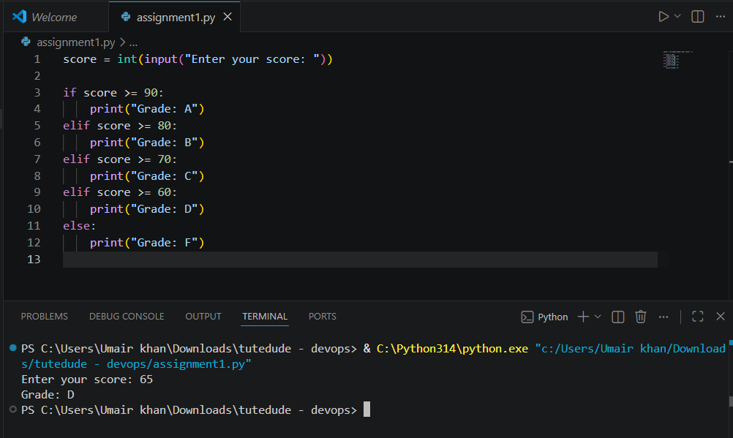
2. Student Grades
Step 1: Create a dictionary for student grades
students = {}
Explanation: A dictionary is used to store student names as keys and their grades as values.
Step 2: Add a new student and grade
name = input("Enter student name: ")
grade = input("Enter grade: ")
students[name] = grade
Explanation: The student's name and grade are taken as input. The student's name is used as the dictionary key and the grade is stored as its value.
Step 3: Update an existing student's grade
name = input("Enter student name: ")
if name in students:
grade = input("Enter new grade: ")
students[name] = grade
print("Grade updated successfully.")
else:
print("Student not found.")
Explanation: The in operator checks whether the student already exists in the dictionary. If the student exists, the grade is updated using students[name] = grade.
Step 4: Print all student grades
for name, grade in students.items():
print(name, ":", grade)
Explanation: The items() function is used to access both the student name and grade. The for loop displays all student grades.
Example Output:
Student Grades:
Umair : A
Rahul : B
Aman : A
Screenshot:
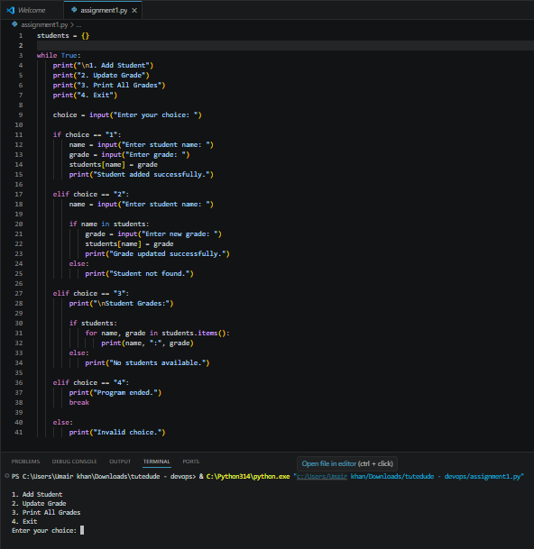
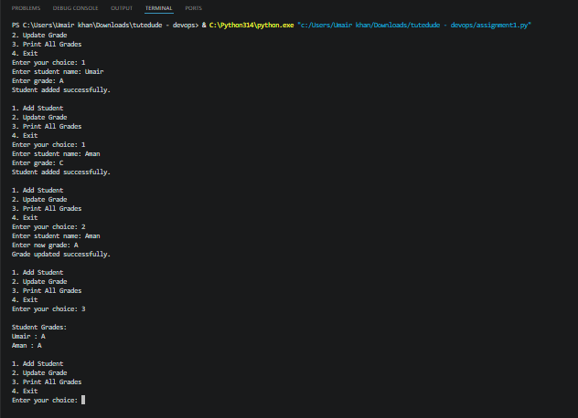
3. Write to a File
Step 1: Create or open a text file in write mode
file = open("student.txt", "w")
Explanation: The open() function is used to create or open a file. The "w" mode means write mode. If the file does not exist, Python creates a new file.
Step 2: Write content into the file
file.write("This is my Tutedude assignment.\n")
file.write("I am learning Python programming.\n")
file.write("This file was created using Python.")
Explanation: The write() function is used to write content into the text file. The \n is used to move the next content to a new line.
Step 3: Close the file
file.close()
Explanation: The close() function is used to close the file after completing the writing operation.
Complete Code:
file = open("student.txt", "w")
file.write("This is my Tutedude assignment.\n")
file.write("I am learning Python programming.\n")
file.write("This file was created using Python.")
file.close()
print("Content written to the file successfully.")
Expected Output:
Content written to the file successfully.
Screenshot:
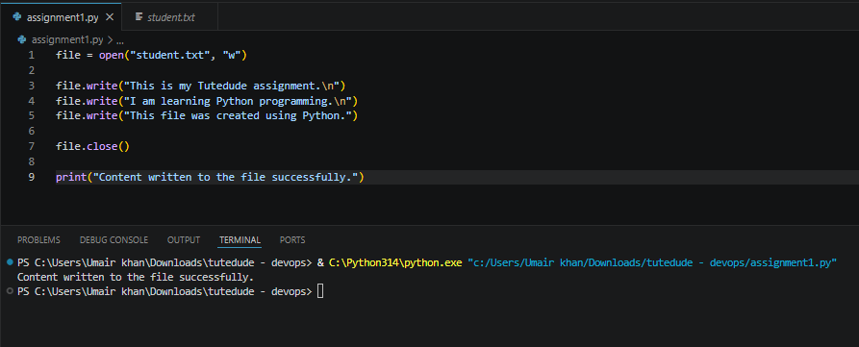
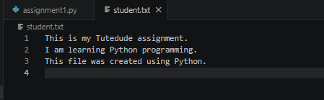
4. Read from a File
Step 1: Open the file in read mode
file = open("student.txt", "r")
Explanation: The open() function is used to open the file. The "r" mode means read mode.
Step 2: Read the contents of the file
content = file.read()
Explanation: The read() function reads the contents of the file and stores them in the content variable.
Step 3: Display the file contents
print("File Content:")
print(content)
Explanation: The print() function is used to display the contents that were read from the file.
Step 4: Close the file
file.close()
Explanation: The close() function is used to close the file after reading its contents.
Complete Code:
file = open("student.txt", "r")
content = file.read()
print("File Content:")
print(content)
file.close()
Expected Output:
File Content:
This is my Tutedude assignment.
I am learning Python programming.
This file was created using Python.
Screenshot: 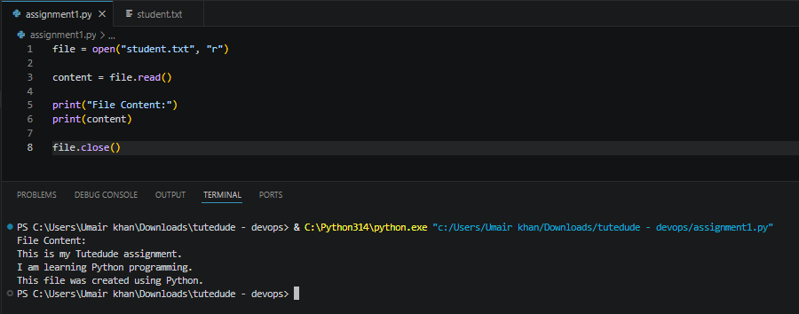

Summary of Concepts
Task / Concept | Python Function / Operation
Take input | input()
Convert input to integer | int()
Decision making | if / elif / else
Store student grades | Dictionary
Add or update grade | students[name] = grade
Check student existence | in
Display dictionary contents | items()
Open or create file | open()
Write to file | write()
Read from file | read()
Close file | close()
Repeat operations | for / while

